**Week 3- Spring Core_Maven Hands On**

**Name- Adi Jain**

**Superset ID- 6390400**

**Exercise 1: Configuring a Basic Spring Application**

**Scenario:**

Your company is developing a web application for managing a library. You need to use the Spring Framework to handle the backend operations.

**Code**

**File name: pom.xml**

<project xmlns="http://maven.apache.org/POM/4.0.0"  
 xmlns:xsi="http://www.w3.org/2001/XMLSchema-instance"  
 xsi:schemaLocation="http://maven.apache.org/POM/4.0.0  
 http://maven.apache.org/xsd/maven-4.0.0.xsd">  
  
 <modelVersion>4.0.0</modelVersion>  
  
 <groupId>com.library</groupId>  
 <artifactId>LibraryManagement</artifactId>  
 <version>1.0-SNAPSHOT</version>  
  
 <properties>  
 <maven.compiler.source>21</maven.compiler.source>  
 <maven.compiler.target>21</maven.compiler.target>  
 <project.build.sourceEncoding>UTF-8</project.build.sourceEncoding>  
 </properties>  
  
 <dependencies>  
 <!-- Spring Context (includes Core and Beans) -->  
 <dependency>  
 <groupId>org.springframework</groupId>  
 <artifactId>spring-context</artifactId>  
 <version>5.3.34</version> <!-- You can change to a newer version if needed -->  
 </dependency>  
 </dependencies>  
  
 <build>  
 <plugins>  
 <!-- Compiler Plugin to use Java 21 -->  
 <plugin>  
 <groupId>org.apache.maven.plugins</groupId>  
 <artifactId>maven-compiler-plugin</artifactId>  
 <version>3.11.0</version>  
 <configuration>  
 <source>21</source>  
 <target>21</target>  
 </configuration>  
 </plugin>  
 </plugins>  
 </build>  
  
</project>

**========================================================**

**File Name: applicationContext.xml**

<?xml version="1.0" encoding="UTF-8"?>  
<beans xmlns="http://www.springframework.org/schema/beans"  
 xmlns:xsi="http://www.w3.org/2001/XMLSchema-instance"  
 xsi:schemaLocation="http://www.springframework.org/schema/beans  
 http://www.springframework.org/schema/beans/spring-beans.xsd">  
  
 <!-- Define BookRepository bean -->  
 <bean id="bookRepository" class="com.library.repository.BookRepository"/>  
  
 <!-- Define BookService bean and inject BookRepository -->  
 <bean id="bookService" class="com.library.service.BookService">  
 <property name="bookRepository" ref="bookRepository"/>  
 </bean>  
  
</beans>

**=======================================================**

**File Name: BookRepository.java**

package com.library.repository;  
  
public class BookRepository {  
 public void save() {  
 System.*out*.println("Book saved to repository.");  
 }  
}

**========================================================**

**File Name: BookService.java**

package com.library.service;  
  
import com.library.repository.BookRepository;  
  
public class BookService {  
  
 private BookRepository bookRepository;  
  
 // Setter for DI  
 public void setBookRepository(BookRepository bookRepository) {  
 this.bookRepository = bookRepository;  
 }  
  
 public void saveBook() {  
 System.*out*.println("BookService: Calling repository to save book...");  
 bookRepository.save();  
 }

}

**========================================================**

**File Name: MainApp.java**

import com.library.service.BookService;  
import org.springframework.context.ApplicationContext;  
import org.springframework.context.support.ClassPathXmlApplicationContext;  
  
public class MainApp {  
 public static void main(String[] args) {  
 ApplicationContext context = new ClassPathXmlApplicationContext("applicationContext.xml");  
  
 BookService bookService = (BookService) context.getBean("bookService");  
 bookService.saveBook();  
 }  
}

**========================================================**

**Output**

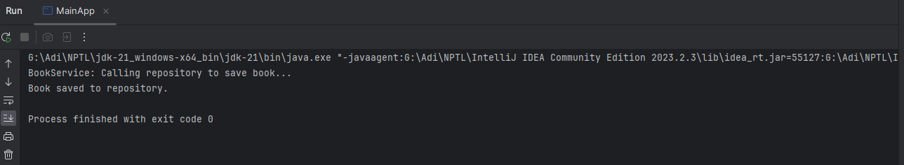

**Exercise 2: Implementing Dependency Injection**

**Scenario:**

In the library management application, you need to manage the dependencies between the BookService and BookRepository classes using Spring's IoC and DI.

**Code**

**File Name: pom.xml**

<project xmlns="http://maven.apache.org/POM/4.0.0"  
 xmlns:xsi="http://www.w3.org/2001/XMLSchema-instance"  
 xsi:schemaLocation="http://maven.apache.org/POM/4.0.0  
 http://maven.apache.org/xsd/maven-4.0.0.xsd">  
  
 <modelVersion>4.0.0</modelVersion>  
  
 <groupId>com.library</groupId>  
 <artifactId>LibraryManagement</artifactId>  
 <version>1.0-SNAPSHOT</version>  
  
 <properties>  
 <maven.compiler.source>21</maven.compiler.source>  
 <maven.compiler.target>21</maven.compiler.target>  
 <project.build.sourceEncoding>UTF-8</project.build.sourceEncoding>  
 </properties>  
  
 <dependencies>  
 <!-- Spring Context (includes Core and Beans) -->  
 <dependency>  
 <groupId>org.springframework</groupId>  
 <artifactId>spring-context</artifactId>  
 <version>5.3.34</version> <!-- You can change to a newer version if needed -->  
 </dependency>  
 </dependencies>  
  
 <build>  
 <plugins>  
 <!-- Compiler Plugin to use Java 21 -->  
 <plugin>  
 <groupId>org.apache.maven.plugins</groupId>  
 <artifactId>maven-compiler-plugin</artifactId>  
 <version>3.11.0</version>  
 <configuration>  
 <source>21</source>  
 <target>21</target>  
 </configuration>  
 </plugin>  
 </plugins>  
 </build>  
  
</project>

**========================================================**

**File Name: applicationContext.xml**

<?xml version="1.0" encoding="UTF-8"?>  
<beans xmlns="http://www.springframework.org/schema/beans"  
 xmlns:xsi="http://www.w3.org/2001/XMLSchema-instance"  
 xsi:schemaLocation="  
 http://www.springframework.org/schema/beans  
 http://www.springframework.org/schema/beans/spring-beans.xsd">  
  
 <!-- BookRepository bean -->  
 <bean id="bookRepository" class="com.library.repository.BookRepository"/>  
  
 <!-- BookService bean with dependency injected -->  
 <bean id="bookService" class="com.library.service.BookService">  
 <property name="bookRepository" ref="bookRepository"/>  
 </bean>  
  
</beans>

**========================================================**

**File Name: BookRepository.java**

package com.library.repository;  
  
public class BookRepository {  
 public void save() {  
 System.*out*.println("Book saved to repository.");  
 }  
}

**========================================================**

**File name: BookService.java**

package com.library.service;  
  
import com.library.repository.BookRepository;  
  
public class BookService {  
  
 private BookRepository bookRepository;  
  
 // ✅ Setter for Spring DI  
 public void setBookRepository(BookRepository bookRepository) {  
 this.bookRepository = bookRepository;  
 }  
  
 public void saveBook() {  
 System.*out*.println("BookService: Calling repository to save book...");  
 bookRepository.save();  
 }  
}

**========================================================**

**File Name: MainApp.java**

package com.library;  
  
import com.library.service.BookService;  
import org.springframework.context.ApplicationContext;  
import org.springframework.context.support.ClassPathXmlApplicationContext;  
  
public class MainApp {  
 public static void main(String[] args) {  
 // Load Spring context from XML  
 ApplicationContext context = new ClassPathXmlApplicationContext("applicationContext.xml");  
  
 // Retrieve BookService bean from context  
 BookService bookService = (BookService) context.getBean("bookService");  
  
 // Test the injected BookRepository  
 bookService.saveBook();  
 }  
}

**========================================================**

**Output**

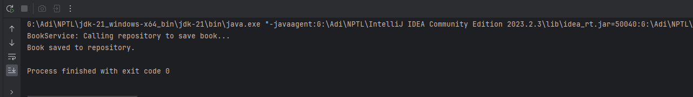

**Exercise 4: Creating and Configuring a Maven Project**

**Scenario:**

You need to set up a new Maven project for the library management application and add Spring dependencies.

**Code**

**File Name: pom.xml**

<project xmlns="http://maven.apache.org/POM/4.0.0"  
 xmlns:xsi="http://www.w3.org/2001/XMLSchema-instance"  
 xsi:schemaLocation="http://maven.apache.org/POM/4.0.0  
 http://maven.apache.org/xsd/maven-4.0.0.xsd">  
  
 <modelVersion>4.0.0</modelVersion>  
  
 <groupId>com.library</groupId>  
 <artifactId>LibraryManagement</artifactId>  
 <version>1.0-SNAPSHOT</version>  
  
 <properties>  
 <maven.compiler.source>1.8</maven.compiler.source>  
 <maven.compiler.target>1.8</maven.compiler.target>  
 </properties>  
  
 <dependencies>  
 <dependency>  
 <groupId>org.springframework</groupId>  
 <artifactId>spring-context</artifactId>  
 <version>5.3.34</version>  
 </dependency>  
  
 <dependency>  
 <groupId>org.springframework</groupId>  
 <artifactId>spring-aop</artifactId>  
 <version>5.3.34</version>  
 </dependency>  
  
 <dependency>  
 <groupId>org.springframework</groupId>  
 <artifactId>spring-webmvc</artifactId>  
 <version>5.3.34</version>  
 </dependency>  
 </dependencies>  
  
 <build>  
 <plugins>  
 <plugin>  
 <groupId>org.apache.maven.plugins</groupId>  
 <artifactId>maven-compiler-plugin</artifactId>  
 <version>3.11.0</version>  
 <configuration>  
 <source>1.8</source>  
 <target>1.8</target>  
 </configuration>  
 </plugin>  
 </plugins>  
 </build>  
</project>

**========================================================**

**File Name: MainApp.java**

package com.library;  
  
import com.library.service.BookService;  
import org.springframework.context.ApplicationContext;  
import org.springframework.context.support.ClassPathXmlApplicationContext;  
  
public class MainApp {  
 public static void main(String[] args) {  
 // Load Spring context from XML  
 ApplicationContext context = new ClassPathXmlApplicationContext("applicationContext.xml");  
  
 // Retrieve BookService bean from context  
 BookService bookService = (BookService) context.getBean("bookService");  
  
 // Test the injected BookRepository  
 bookService.saveBook();  
 }  
}

**========================================================**

**Output**

